(Approx. 910 words)

Desktop Linux Mint 19.3
By Tom Burt, Vice-President, Sun City Summerlin Computer Club
www.scscc.club
tomburt89134 (at) cox.net

Even though I’m predominantly a Windows 10 user, every 18 months or so, I teach a seminar on “What’s New with Linux.” As you might guess, it doesn’t usually draw much of a crowd. My favorite “distro” (version) is Linux Mint because it’s free (open source), it comes with a very nice graphical desktop (actually, a choice of three), it includes lots of bundled applications, it’s well-supported and it performs great on old, low-end hardware. Also, because it is internal design, Linux is innately very secure. With Windows 7 losing support from Microsoft as of January 14th, if you’re now among the Windows 7 orphans, you might want to consider installing Linux Mint to replace or run alongside Windows 7 on your “well-seasoned” PC. Following is an overview of Linux Mint 19.3, the newest version released in December 2019.

How to Get and Install Linux Mint 19.3
Browse to: https://linuxmint.com/. The home page has lots of links to information about Linux. Click one of the buttons to choose which desktop version (Cinnamon, Mate or Xfce) to download. A page of information, including download links, will appear. Click one of the “USA” download links to download a 64-bit “ISO” (DVD) image file to a folder on your PC’s hard drive.
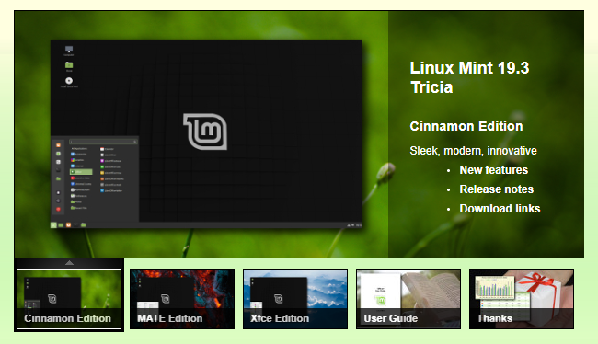
LinuxMint.org Home Page with Cinnamon Desktop Version selected
Once the Linux Mint ISO download is complete, you can burn the ISO image to a DVD to make a bootable setup DVD. Or, you can download and use a free program called balena Etcher (https://www.balena.io/etcher/) to convert the ISO image to a bootable USB flash drive.
To get a feel for Linux Mint, you can simply boot and run Linux Mint from the boot media without installing it. This is called a “live session”. The live session desktop includes an “Install Linux” icon that will let you install Linux. In the installer, you can choose to replace the current operating system, or you can install Linux Mint alongside the current operating system. This will configure your PC to dual-boot Linux and Windows. The 64-bit Linux Mint configuration defaults are fine and the installer will automatically handle secure boot and UEFI issues.
For comprehensive Linux Mint installation instructions, see:
https://linuxmint-installation-guide.readthedocs.io/en/latest/index.html
Another alternative is to set up Linux Mint in a virtual machine. For this, I use Oracle Virtual Box (https://virtualbox.org). After the empty virtual machine has been set up, boot it from the Linux Mint ISO and install Linux Mint to the virtual machine’s virtual hard drive. To learn more, see my Virtual Machine seminar at https://www.scscc.club/smnr/Virtual_Machine_Primer.pdf.

Exploring Linux Mint Cinnamon
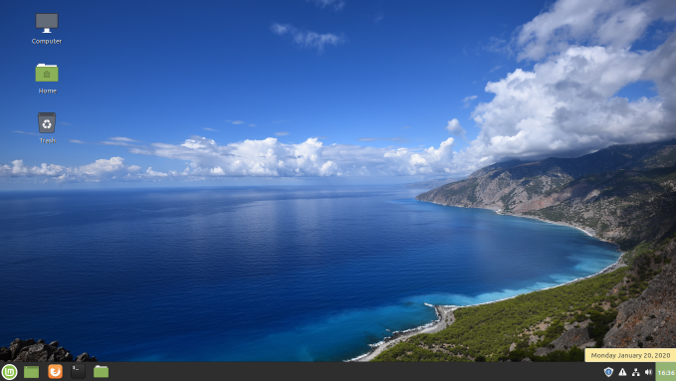
Linux Mint with Cinnamon Desktop
Linux Mint is a Windows 7 work-alike, so it’s relatively easy for a Windows user to get going with it. The above screenshot of the desktop shows desktop icons, a Task Bar with a Start button, “quick launch” icons and a tray area, and a customizable desktop background.

You open the Start Menu by clicking the button in the lower-left corner. The Start Menu has a pane at the left for launching key applications and functions, a search window at the top, a column of application categories, and, for a selected category, a list of the applications in that category. A scroll bar appears at the right edge when needed.
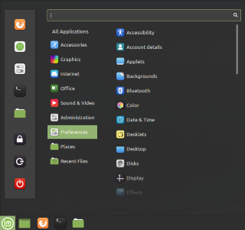
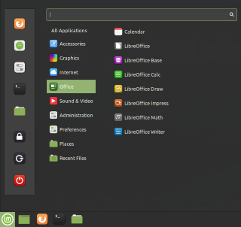
Linux Mint Cinnamon Start Menu Screen Shots
Among the bundled applications in Mint 19.3 is Libre Office, which includes a spreadsheet, word processor, presentation graphics, drawing and flowcharting, and several others. Libre Office can open and save in MS Office file formats. The Firefox web browser and the Thunderbird email program are also bundled. Mint 19.3 features a new video player named Celluloid and a music player named Rhythmbox. Accessories include a calendar, calculator, file viewer, a password manager, and a note-taking tool.
The Preferences settings tool allows you to customize the look and feel of Linux Mint. This includes choosing your desktop background (pictures, solid colors, gradients).

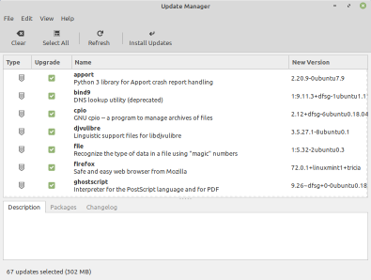
The Update Manager handles checking for and installing updates to Linux Mint and its applications. The Update Manager alerts when new updates are available via its tray icon, but YOU decide when to actually download and install them. To launch it, click its icon on the tray. You can select any or all of the available updates. Generally, you will want to install all of them.

The Software Manager allows you to access Mint’s online repository which claims over 60,000 free, open-source applications and install whichever ones you desire. Launch the Software Manager from Start Menu > Administration > Software Manager. When you click the link for an item, it opens a detail page to help you decide whether the program is what you’re looking for.
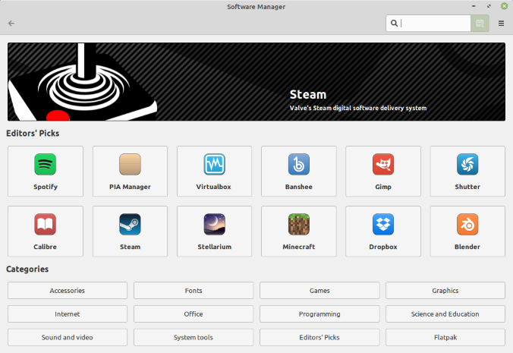

Final Thoughts
I set up Linux Mint 19.3 in a Virtual Box virtual machine to get the screenshots for this article. I booted the virtual machine from the downloaded Mint 19.3 64-bit ISO image and then double-clicked the “Install” icon on the desktop. Other than that, I made a few clicks to select language, keyboard, and time zone and entered my account credentials. The entire setup was done in about 15 minutes. I chose a desktop background and was ready to go. My virtual machine boots to the Linux desktop in about 15 seconds. What could be easier?

That’s about all I can cover in my allotted space. Check out my Linux seminar handout at:
https://www.scscc.club/smnr/Desktop_Linux_Fresh_Look.pdf.

